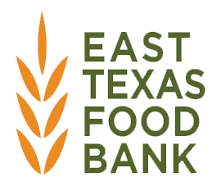
SNAP Community Assistance Partner (CAP) Program

Community Assistance Partners will receive incentives for the facilitation of application assistance in the form of a monthly auto grant on their account at the East Texas Food Bank.
Platinum Level
If an agency serves 1000+ households each month, and reach their goal of 40 submitted applications, they will receive $800 each month.
Gold Level
If an agency serves 400-999 households each month, and reach their goal of 25 submitted applications, they will receive $500 each month.
Silver Level
If an agency serves 100-399 households each month, and reach their goal of 15 submitted applications, they will receive $300 each month.
Bronze Level
If an agency serves less than 100 households each month, and reach their goal of 5 submitted applications, they will receive $100 each month.
An agency MUST meet the application goal to receive compensation at each level.
If an agency meets the household requirement but not the application goal, they will be compensated at the next lower level if those requirements are met. If funds allow, and an agency exceeds the application goal, they will be compensated at a higher tier level.

Please circle your chosen tier level: Platinum Gold Silver Bronze

Agency Name: ____________________________________County: _____________________________
Agency Representative Signature: _________________________________________________________
Print Name: ______________________________________Title: _______________________________

